

MCCLOUD: PREVIOUS PUBLIC SECTOR SERVICE FORM

Pensions Helpdesk (01224) 045 045

E-mail: pensions@nespf.org.uk

Web: www.nespf.org.uk

WHAT YOU NEED TO KNOW
Some LGPS members are protected by the McCloud remedy. You can find out more about the McCloud remedy on our website: www.nespf.org.uk/resources/mccloud/
Protection depends on when you were a member of the Local Government Pension Scheme and any other public service pension scheme. Use this form to let the North East Scotland Pension Fund know about any other relevant pension scheme membership.
What is a public service pension scheme?
A public service pension scheme is a UK pension scheme for:

• civil servants
• the judiciary
• the armed forces
• local government workers
• health service workers
• teachers
• fire and rescue workers
• members of the police force
Do I need to fill in the form?
You only need to fill in the form if you were a member of a public service pension scheme before you joined the LGPS in the North East Scotland Pension Fund. You do not need to complete the form if:
• the only public service pension scheme you have been a member of is the LGPS in the North East Scotland Pension Fund
• you were a member of a public service pension scheme before you joined the LGPS in the North East Scotland Pension Fund, but that membership has been transferred to the North East Scotland Pension Fund
• you first joined a public service pension scheme after 31 March 2012

What do I need to include in the form?
You do not need to tell us about:
• membership of a public service pension scheme after you left the North East Scotland Pension Fund (you might need to complete a form like this for the scheme you joined later)
• membership of a public service pension scheme that ended before 1 April 2007
• a survivor pension you are receiving from a public service pension scheme
• a pension credit in a public service pension scheme – this is a benefit awarded to you as part of a pension share following a divorce or dissolution of a civil partnership.

What happens next?
We will use the information you provide to find out whether you are protected by the McCloud remedy. We may need to ask for more information from your previous pension administrator. If you are protected, we aim to include an estimate of what this means for your pension in your next annual benefit statement. We will take account of your protection in other figures we produce for you, such as retirement estimates.

How do I return the form?
By email: pensions@nespf.org.uk
By post: NESPF, Level 1, 2 MSq, Marischal Square, Broad St, Aberdeen, AB10 1LP
Upload to the member portal: My Pension+ at https://nespf.pensiondetails.co.uk/

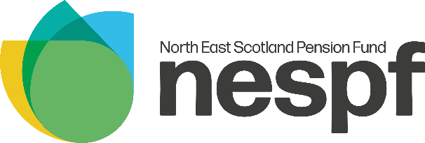
MCCLOUD: PREVIOUS PUBLIC SECTOR SERVICE FORM

Please read the notes above carefully before completing this form.
 | PART 1 - MEMBER’S PERSONAL INFORMATION
Full Name: |  |  | National Insurance  Number:
Email Address: |  |  | Date of Birth:
Home Address:

 | PART 2 - PREVIOUS PENSION SCHEME MEMBERSHIP
 | Scheme name* | Reference / plan number | Date from and to | Contributions refunded?
 |  |  |  | YES |  | NO
 |  |  |  | YES |  | NO
 |  |  |  | YES |  | NO
 |  |  |  | YES |  | NO
* If you were a member of the LGPS, Firefighters’ Pension Scheme or Police Pension Scheme, please include the name of the relevant LGPS Pension Fund, Fire and Rescue Authority or Police Authority

PART 3: DECLARATION
I give my consent for the North East Scotland Pension Fund to get information about previous pension scheme membership from the schemes named above.
Signature: |  | Date:

