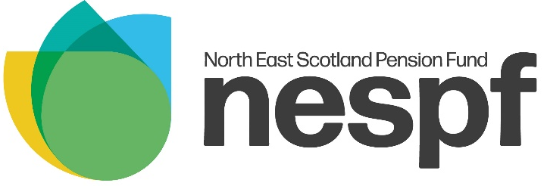
Refund Application Form
DISCLAIMER: Only complete this form if you have already left LGPS Scotland. If you are looking to opt out of the pension scheme, complete the Opt Out Form.
Declaration & Signature

I certify that:

- I have not re-joined the Local Government Pension Scheme (LGPS) Scotland within 1 month and 1 day of ceasing the employment in respect of which I am claiming the refund of pension contributions; and

- I am not currently making contributions to the LGPS in Scotland; and

- I do not already hold a deferred benefit in the LGPS in Scotland; and I am not in receipt of a pension from the LGPS in Scotland, other than a survivor’s pension or a pension awarded to me as part of a Pension Sharing settlement following divorce or dissolution of a civil partnership; and

- I have not previously transferred pension rights from the LGPS Scotland to an overseas pension scheme; and

- I have not previously transferred pension rights into the LGPS Scotland from a scheme that does not permit refunds

I acknowledge that if I make a false declaration, any payment of a refund will mean that I cease to be entitled to any other pension benefits I have in the LGPS in Scotland and that I will have no further claim on the relevant Pension Fund, administering authority or employing authority in respect of those pension benefits.

Print Name
Signature
Date
PTO

Bank Details

Please provide details of the bank account you wish your refund to be paid to. This account must be in your own name and we cannot make payments to Post Office card accounts. For overseas accounts, please contact us.

Name(s) on Account
Name of Bank / Building Society
Sort Code |  | --
Account Number
Building Society Reference Number
Contact Details

If there are any issues with this form or the details provided, it could delay payment of your pension. Please provide your contact details.

Contact Phone Number

Email Address

Once complete return this form to:
North East Scotland Pension Fund,
Level 1,
2 MSq,
Marischal Square,
Broad Street,
Aberdeen,
AB10 1LP

If you have any questions or concerns about completing this form, please contact the Pension Fund or your bank or building society for advice.

Leaving the Pension Scheme Factsheet
Refund of Contributions
Eligibility of a refund
A refund is only available if you meet all the below criteria:
- You have under 2 years qualifying service (includes service with other LGPS Scotland funds)
- You do not become a member of LGPS Scotland within 1 month & 1 day of leaving
- You are not making contributions in the LGPS Scotland
- You are not receiving a pension (other than survivor’s pension), have deferred benefits, or have a frozen refund in the LGPS Scotland
- You have not previously transferred any pension rights from the LGPS Scotland to an overseas scheme or previously transferred in pension rights from a scheme that does not permit refunds

As pension contributions receive full tax relief, in line with the Finance Act 2004, a pension fund tax of 20% is deducted from all refunds.

There may be further restrictions on taking a refund of pension contributions if you leave the LGPS in or after the financial year in which you attain State Pension Age.

AVCs
If you have been paying Additional Voluntary Contributions (AVCs) to Prudential, you will receive a refund of your AVCs (minus tax) as well.

Transferring Your Pension

A transfer out is only available if you paid into the pension scheme for more than 3 months and the transfer is completed 12 months before your Normal Pension Age (NPA) in the LGPS. Your NPA is your State Pension Age, or age 65 if later.

Many pension providers only allow a transfer if the request is made within a year of joining, therefore if you wish to transfer you should contact your new provider as soon as possible.

Your new pension provider must request a transfer value quotation, which we will guarantee for a period of three months from the date of calculation, known as the ’Guarantee Date’. Your new pension provider can then advise you of the additional benefits the transfer will buy in their scheme. All transfer values are calculated in accordance with LGPS Regulations.

Transfers to public sector schemes usually give benefits that are broadly equivalent to those in the LGPS, provided you apply for the transfer within twelve months of joining your new pension scheme and there is no continuous break in active membership of public sector pension schemes of more than 5 years.

Transferring your pension rights is not always an easy decision to make, and you may wish to seek the help of an independent financial adviser before you make a decision to transfer.

If you are changing your job, but still working in Local Government or for another employer participating in the LGPS, then you can ask for the pension rights from your old job to be transferred to your new job. If you choose to transfer your benefits, you will have one set of benefits which will be based on your entire period of LGPS service.

Disclaimer: The information in these notes is based on the Local Government Pension Scheme (Scotland) Regulations and other relevant legislation. It is for general use and cannot cover every personal circumstance. In the event of any dispute over pension benefits, the appropriate legislation will prevail as these notes do not confer any contractual or statutory rights and is provided for information purposes only

