

«TITLE» «FIRSTNAME» «LASTNAME»

«ADDRESS1»

«ADDRESS2»

«ADDRESS3» Our Reference:

«ADDRESS4» **CPHLR0521/1**

«POSTCODE»

Plan name:

**<Plan name>**

Plan number:

**<Plan number>**

June 2021

Dear Pension Manager

# Our service performance

As you may be aware, we have experienced some significant delays in the processing of investments and claims. I am very sorry for the impact of these delays on you as a client of Prudential and upon your scheme members.

We are working through a service recovery plan which aims to bring our service levels back to normal, and provide you and your members with the quality of support you deserve.

To help with this recovery, we have recruited additional colleagues to improve the performance in all areas.

We have made material improvements over the last year to the processing time for a retirement claim, and I expect this to continue to improve. However, there are some older claims we are addressing as a matter of priority.

# Complaints

Affected members have rightly taken action to complain to us about the service received. We are addressing these complaints and, where appropriate, paying compensation.

Contribution processing

We have also experienced delays in the processing of contributions. We have taken action to ensure that where an investment has been delayed, the date of processing reflects the date of receipt, rather than the date of processing; ensuring that scheme members are not ‘out of market’ for a significant period of time.

One of the challenges we have experienced in dealing with the backlog of processing is that contributions and the supporting data provided by payroll administrators are not always correctly referenced or have incomplete data. The payroll administrators have been contacted for additional information where required. We will be doing more work with them to improve the format and referencing of payments and data. This will, in turn, help us to improve the service we provide.

# Scheme Revisions and Annual Benefit Statements

As a consequence of the servicing delays outlined above, unfortunately there is a timing impact on the production of the annual scheme revision information and Annual Benefit Statements. The provision of your scheme annual revision information is expected to be at least 8 weeks later than usual.

I am very conscious of the impact delays of this kind have on you and your members. We are working to produce the scheme revision information and Annual Benefit Statements as quickly as possible.

I know this information will be unwelcome and I’m sure, will cause additional concern to you as a client of Prudential. We have informed the Pensions Regulator of the delays and challenges you and your members have experienced.

I would like to re-affirm our commitment to improving the service we provide to you and your members, and we will update you regularly on our progress.

Yours faithfully

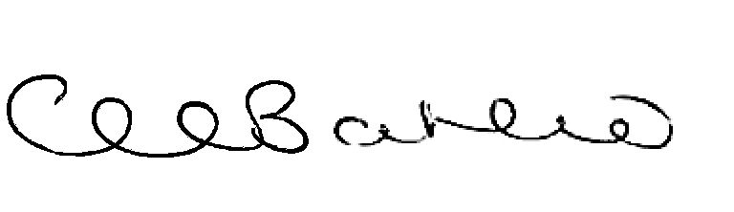

Clare Bousfield

Director of Prudential Assurance Company Limited